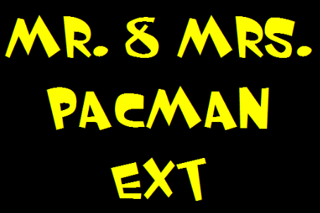

users guIde

**Table of Contents**

Introduction

**System Requirements**

Game Overview

**Playing the Game**

**Game Objects**

Pac-Mans

Ghosts

Blinky

Pinky

Inky

Clyde

Food

Basic Food

Big Basic Food

Green Food

Yellow Food

Shields

Copper Shield

Silver Shield

Gold Shield

Create Map

Credits

**Introduction**

Mr. & Mrs. Pac-Man Extended is a platform game which is similar to conventional Pac-Man arcade game. Player’s aim is to pass levels by collecting all food on the map. Ghosts are enemies of the player. By collecting food player increases its score which is required to buy shields which give new abilities to Pac-mans.

System Requirements

Mr.&Mrs. Pac-Man Extended is a Java based arcade game. Therefore, to launch the game, user must have java runtime environment (jre) which can be easily found. The game can be launched in common operating systems.

Recommended System Requirements:

• Windows 10, Linux, MacOS

• Intel core 2 duo 1.6 GHz CPU or higher

• 256 MB of RAM or higher.

• Screen Resolution: 800x600

**Game Overview**

By double clicking desktop icon of the game, player will see main menu which contains single player, two players, create map, load game, load map, high score and help options. After selecting single player or two players, game will start from level 1. The game consists of three levels. At the end of each level, a pop up panel that shows various shields will appear. These shields make the Pac-Man faster and it gains resistance against ghosts according to shield’s features. Player can buy a shield by spending his/her scores. Player’s scores will increase by eating food and ghosts. If player spends all lives, game will be over and program will ask for a name if s/he reached a high score.

In the create-map mode, player can design his/her own map and can state location and number of ghosts. The player will create his/her own challenge and if the use wants to keep the level that he created, he can save the map for another use. The gap between the bricks will let the user to escape across the map and the user is also able to determine the place and amount of food.

**Playing the Game**

-How to start the game?

In the main menu player can start the game by clicking one or two player option. Player can also play saved games by clicking load game. Another option is to play created map.

Controls

Mr. Pacman: Arrow Keys

Mrs. Pacman: Up: W, Down: S, Right: D, Left: A

-How to pause the game?

While playing the game, player can stop the game by clicking “Esc” key on the keyboard. Resume button simply resumes the game. Exit button provides going back to main menu without saving the game. If player clicks save game button on pause menu, program will ask player for name of the saving game.

-How to change sound?

By clicking sound icon on the main menu, player can enable or disable the sound.

**Game Objects**

Pac-Mans

Both Mr. & Mrs. Pac-Man will have the same features in terms of their abilities. Differences are their appearance and controllers -the players that play them- . Mr. Pac-Man can be managed by using up, down, right and left arrows and Mrs. Pac-Man can be managed by using W, A, S, D.

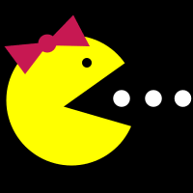 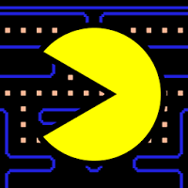

Ghosts

**Ghosts**

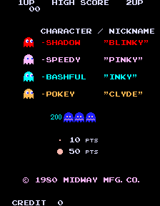The ghost types of the classical Pac-Man game will be used in our version.

**Blinky** 

It is the red ghost, known as the leader ghost of the group. It is following the Pac-Man from behind.

**Pinky** 

It is the pink ghost and it positions in front of Pac-Man all the time.

**Inky** 

It is the blue ghost which has a fickle mood. It is unpredictable.

**Clyde** 

It is the orange ghost which is considered to be stupid. It chases Pac-Man with the lead of Blinky but it wanders off to its home corner when he gets too close.

Scattered Mode 

If player eats big food, ghosts become in scattered mode for five seconds.

Food

**Basic Food** 

This kind of food does not give any new ability to pacmans. Player has to eat all basic food to pass the next level. When a basic food is eaten, player will get ten points.

**Big Basic Food** 

This kind of food gives pacman opportunity to eat ghosts for five seconds and this food gives forty points.

**Green Food** 

Green food is new type of food. This food provides passing through walls for five seconds and gives fifty points.

**Yellow Food** 

Yellow food is also new type of food. This food provides passing through ghosts for five seconds and gives fifty points.

Shields

**Copper Shield **

Copper shield is the cheapest and weakest shield of the game. If player buys this copper shield, player’s pacman will able to hit the ghosts without dying for fifteen seconds after game starts. Cost of copper shield is 3000 points.

**Silver Shield **

If player buys this silver shield, player’s pacman will able to hit the ghosts without dying for twenty seconds after game starts. Cost of silver shield is 6000 points.

**Gold Shield **

Gold shield is the most powerful and expensive shield of the game. This shield provides hitting a ghost for fifteen seconds without dying after game starts. Gold shield also increases speed by twice. Cost is 9000 points.

Create Map

If player clicks Create Map button in the main menu, create map screen appears. On this screen player can create its own map and can state number of players and ghosts.

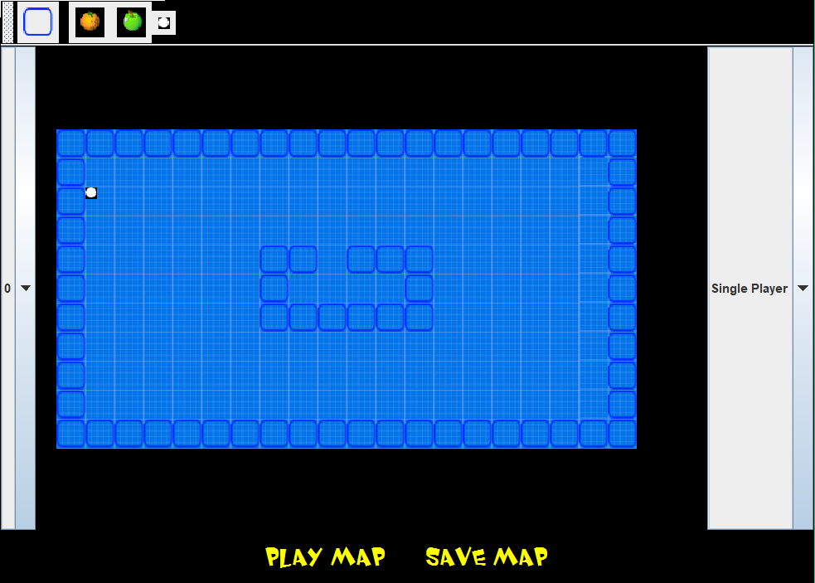

On toolbar there are items to be added to map. By clicking items, player can place items. It is enough to delete an item by clicking this item after choosing this item from toolbar. Player can adjust number of ghosts from combo box on the left side. Not to have some problems, some grids are forbidden. For example, player cannot place an item onto where ghosts are spawn.

credits

Ecem İlgün

Talha Şeker

Aziz Osman Kozhan

Başak Şevval Ekici

